Major Earth Resources

Natural Resources
- What is a resource?

- List the major natural resources on Earth.

Renewable and non-renewable resources
- What determines whether a resource is renewable or not?

- What is a renewable resource?

- Give two examples of renewable resources.

- What is a non-renewable resource?

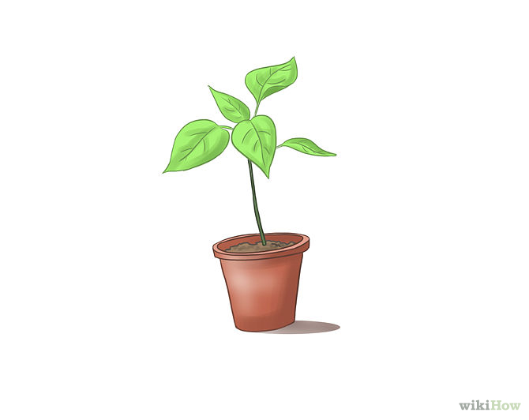
- Give two examples of non-renewable resources.

Living things as a resource
- Living things are a resource for _________ and ___________________.
- They provide ________ and ____________ for other organisms.
- Forests that are cut down can be ____________ and animals, like cows, can be replaced through ________________.
- Living things are a ______________ resource.
Air as a resource
- Air is a mixture of _______, _______ and ___________________.
- Oxygen in the air is used by ___________ and ___________, but is constantly being replaced by ___________.

- Carbon dioxide in the air is used by __________ to make their own _______, but is constantly being replaced by ___________.
- Air is a ______________ resource.

Sunlight as a resource
- Plants use sunlight to ___________________.
- Sunlight warms the Earth’s __________________, ________ and __________.
- The sun is a _______ and will produce energy for ______________________.
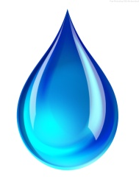
- Sunlight is a ______________ resource.

Water as a resource
- All living things need _______ to __________.
- Water can move from place to place through the __________________.
- Some new water is made each day, but it is thought that the total amount of water on Earth has not changed much since Earth was formed.
- Water is a ______________ resource.

Rocks as a resource
- Rocks provide two different resources: the _________________ and the ____________ in the rocks.
- Most of the rocks formed on the Earth were formed ___________________________.

- Only a tiny fraction of the Earth’s rocks are being replaced each year.
- Rocks are a _________________ resource.

Oil and coal as resources
- Oil and coal are materials found _________________________________________.

- They were formed from _______ __________and ___________ that lived millions of years ago.
- Oil and coal are _________________ resources.

Soil as a resource
- Rocks can be worn away by _____________ and ___________ to form _____________.
- Sediments are carried away and deposited making new soil and renewing old soil.
- It takes hundreds or thousands of years to form a few ________________ of soil.
- Human activities have ______________ this cycle so soils are not being ____________.
- Soil is a _________________ resource.

